SCD-LAB-07
22K-5195
1)
<%@ page contentType="text/html;charset=UTF-8" language="java" %>
<!DOCTYPE html>
<html lang="en">
<head>
<meta charset="UTF-8">
<meta name="viewport" content="width=device-width, initial-scale=1.0">
<link rel="stylesheet" href="https://stackpath.bootstrapcdn.com/bootstrap/4.5.2/css/bootstrap.min.css">
<title>Task-1</title>
<style>
html, body {
height: 100%;
margin: 0;
}
.wrapper {
display: flex;
flex-direction: column;
min-height: 90vh;
}
.content {
flex: 1;
}
footer {
background-color: #36454F; /* Change as needed */
text-align: center;
padding: 1rem 0;
}
</style>
</head>
<body>
<nav class="navbar navbar-expand-lg navbar-light bg-light">
<div class="collapse navbar-collapse">
<ul class="navbar-nav">
<li class="nav-item <%= request.getRequestURI().endsWith("index.jsp") ? "active" : "" %>">
<a class="nav-link" href="index.jsp">Home</a>
</li>
<li class="nav-item <%= request.getRequestURI().endsWith("about.jsp") ? "active" : "" %>">
<a class="nav-link" href="about.jsp">About</a>
</li>
<li class="nav-item <%= request.getRequestURI().endsWith("contact.jsp") ? "active" : "" %>">
<a class="nav-link" href="contact.jsp">Contact</a>
</li>
<li class="nav-item <%= request.getRequestURI().endsWith("register.jsp") ? "active" : "" %>">
<a class="nav-link" href="register.jsp">Register</a>
</li>
<li class="nav-item <%= request.getRequestURI().endsWith("signup.jsp") ? "active" : "" %>">
<a class="nav-link" href="signup.jsp">Signup</a>
</li>
</ul>
</div>
</nav>

<%@ page contentType="text/html;charset=UTF-8" language="java" %>
<footer style="background-color: #89eed4; text-align: center; padding: 1rem 0;">
<div class="text-center">
K224818
</div>
</footer>
<script src="https://code.jquery.com/jquery-3.5.1.slim.min.js"></script>
<script src="https://cdn.jsdelivr.net/npm/@popperjs/core@2.11.6/dist/umd/popper.min.js"></script>
<script src="https://stackpath.bootstrapcdn.com/bootstrap/4.5.2/js/bootstrap.min.js"></script>

<%@ page contentType="text/html;charset=UTF-8" language="java" %>
<%@ include file="/common/header.jsp" %>
<div class="wrapper">
<div class="content container">
<h1>About Us</h1>
<p>This page gives you information about us.</p>
</div>
<%@ include file="/common/footer.jsp" %>
</div>

<%@ page contentType="text/html;charset=UTF-8" language="java" %>
<%@ include file="/common/header.jsp" %>
<div class="wrapper">
<div class="content container">
<h1>Contact Us</h1>
<p>This is the contact page.</p>
</div>
<%@ include file="/common/footer.jsp" %>
</div>

<%@ page contentType="text/html;charset=UTF-8" language="java" %>
<%@ include file="/common/header.jsp" %>
<div class="wrapper">
<div class="content container">
<h1>Welcome to the Home Page!</h1>
<p>This is the home page of your website.</p>
</div>
<%@ include file="/common/footer.jsp" %>
</div>

<%@ page contentType="text/html;charset=UTF-8" language="java" %>
<%@ include file="/common/header.jsp" %>
<div class="wrapper">
<div class="content container">
<h1>Register</h1>
<form>
<div class="form-group">
<label for="username">Username</label>
<input type="text" class="form-control" id="username" placeholder="Enter username">
</div>
<div class="form-group">
<label for="password">Password</label>
<input type="password" class="form-control" id="password" placeholder="Password">
</div>
<button type="submit" class="btn btn-primary">Register</button>
</form>
</div>
<%@ include file="/common/footer.jsp" %>
</div>

<%@ page contentType="text/html;charset=UTF-8" language="java" %>
<%@ include file="/common/header.jsp" %>
<div class="wrapper">
<div class="content container">
<h1>Signup</h1>
<form>
<div class="form-group">
<label for="email">Email address</label>
<input type="email" class="form-control" id="email" placeholder="Enter email">
</div>
<div class="form-group">
<label for="password">Password</label>
<input type="password" class="form-control" id="password" placeholder="Password">
</div>
<button type="submit" class="btn btn-primary">Signup</button>
</form>
</div>
<%@ include file="/common/footer.jsp" %>
</div>

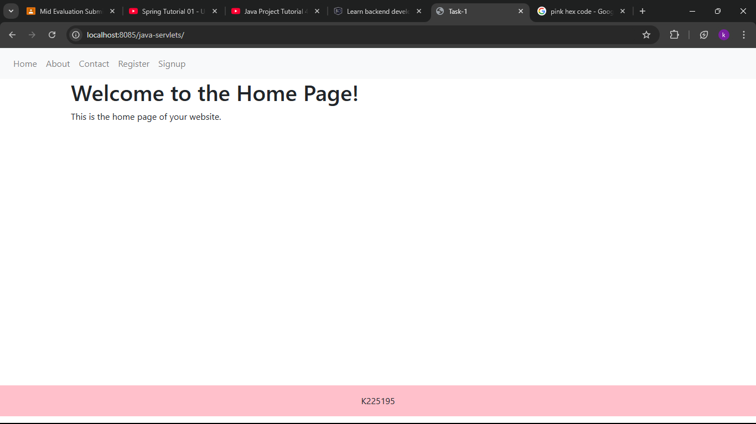
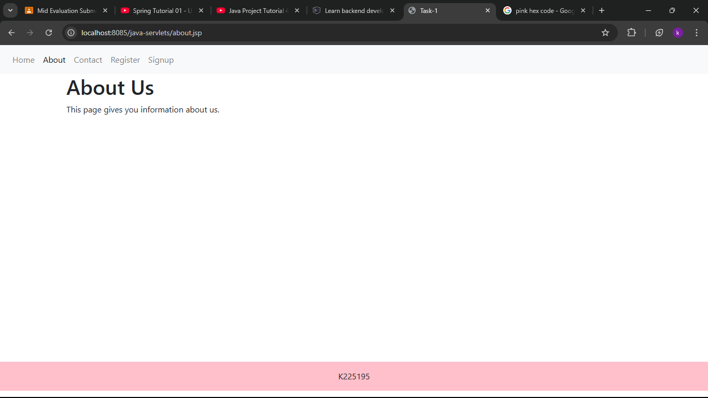
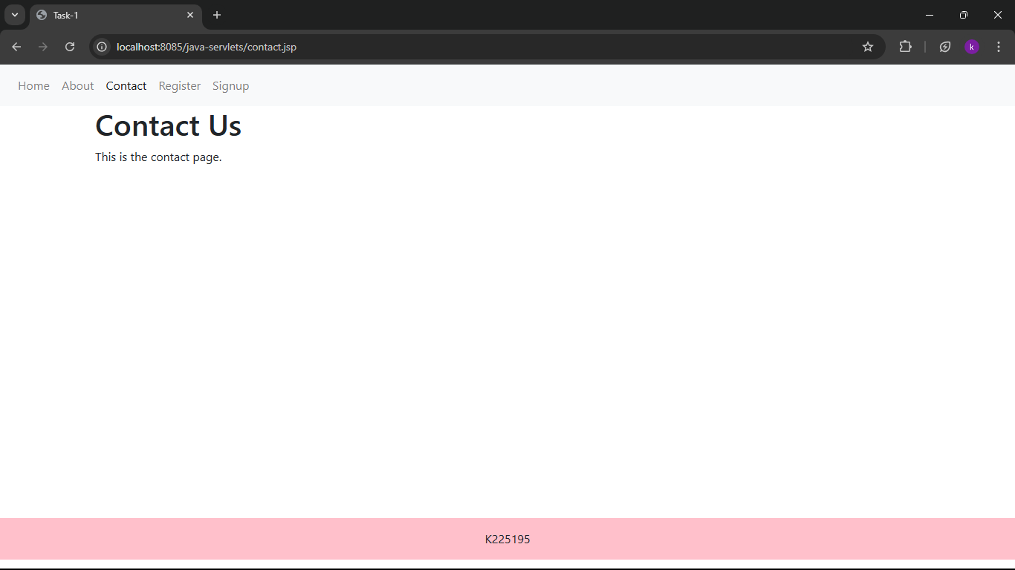
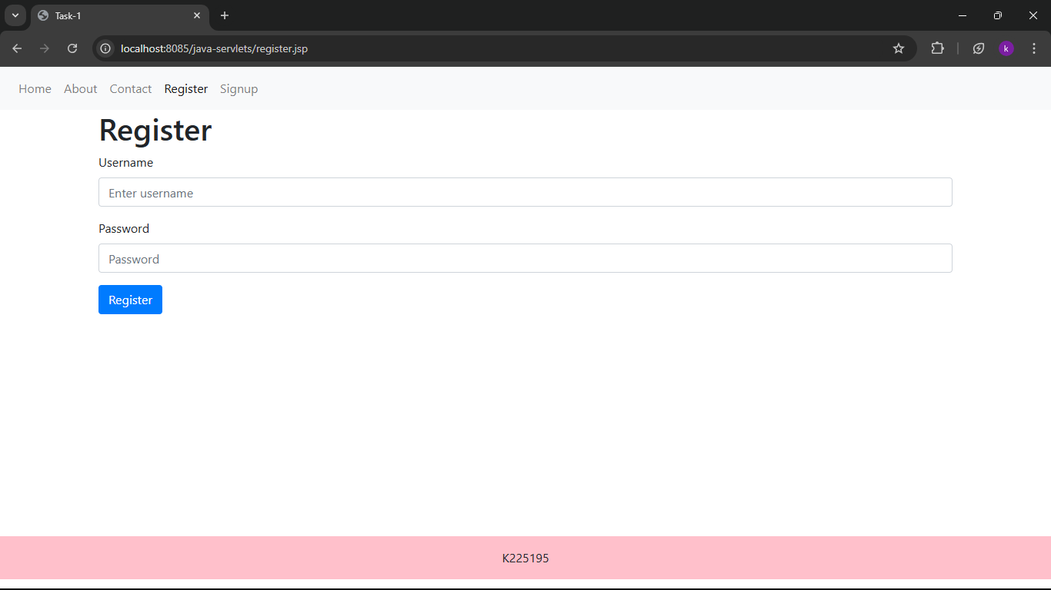
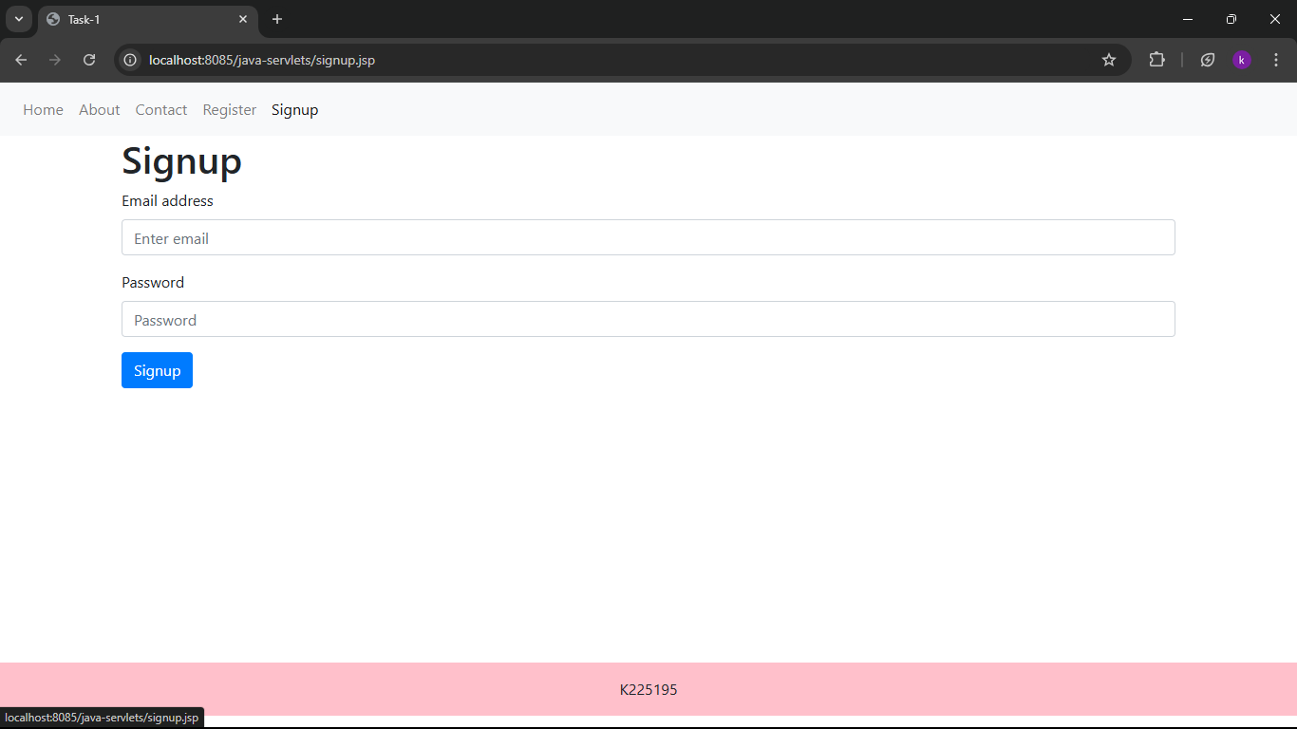

2)
<%@ page language="java" contentType="text/html; charset=UTF-8" pageEncoding="UTF-8"%>
<!DOCTYPE html>
<html>
<head>
<title>Employee Salary Calculator</title>
<style>
body {
font-family: Arial, sans-serif;
margin: 0;
padding: 20px;
background-color: #f4f4f4;
}
form {
background: #fff;
padding: 20px;
border-radius: 5px;
box-shadow: 0 0 10px rgba(0, 0, 0, 0.1);
}
input[type="text"], input[type="number"] {
width: 100%;
padding: 10px;
margin: 10px 0;
border: 1px solid #ccc;
border-radius: 4px;
}
input[type="submit"] {
background: #5cb85c;
color: white;
border: none;
padding: 10px 15px;
border-radius: 4px;
cursor: pointer;
}
input[type="submit"]:hover {
background: #4cae4c;
}
.result {
margin-top: 20px;
font-weight: bold;
}
.error {
color: red;
}
</style>
</head>
<body>

<h2>Employee Salary Calculator</h2>

<%
String name = request.getParameter("name");
String basicSalaryStr = request.getParameter("basicSalary");
String allowancesStr = request.getParameter("allowances");
String deductionsStr = request.getParameter("deductions");

String errorMessage = "";
double netSalary = 0;

if (name != null && basicSalaryStr != null && allowancesStr != null && deductionsStr != null) {
if (name.trim().isEmpty() || basicSalaryStr.trim().isEmpty() ||
allowancesStr.trim().isEmpty() || deductionsStr.trim().isEmpty()) {
errorMessage = "All fields are required.";
} else {
try {
double basicSalary = Double.parseDouble(basicSalaryStr);
double allowances = Double.parseDouble(allowancesStr);
double deductions = Double.parseDouble(deductionsStr);
netSalary = basicSalary + allowances - deductions;
} catch (NumberFormatException e) {
errorMessage = "Please enter valid numbers for salary, allowances, and deductions.";
}
}
}
%>

<form method="post" action="">
<label for="name">Employee Name:</label>
<input type="text" id="name" name="name" value="<%= name != null ? name : "" %>">

<label for="basicSalary">Basic Salary:</label>
<input type="number" id="basicSalary" name="basicSalary" value="<%= basicSalaryStr != null ? basicSalaryStr : "" %>">

<label for="allowances">Allowances:</label>
<input type="number" id="allowances" name="allowances" value="<%= allowancesStr != null ? allowancesStr : "" %>">

<label for="deductions">Deductions:</label>
<input type="number" id="deductions" name="deductions" value="<%= deductionsStr != null ? deductionsStr : "" %>">

<input type="submit" value="Calculate Net Salary">
</form>

<% if (!errorMessage.isEmpty()) { %>
<div class="error"><%= errorMessage %></div>
<% } else if (name != null) { %>
<div class="result">
Net Salary for <%= name %>: <%= netSalary %>
</div>
<% } %>

</body>
</html>

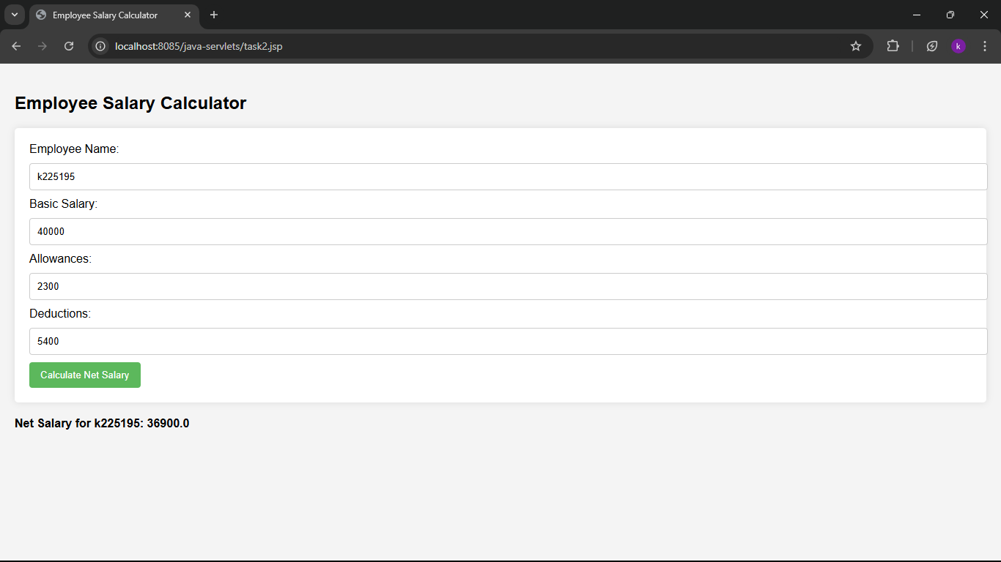
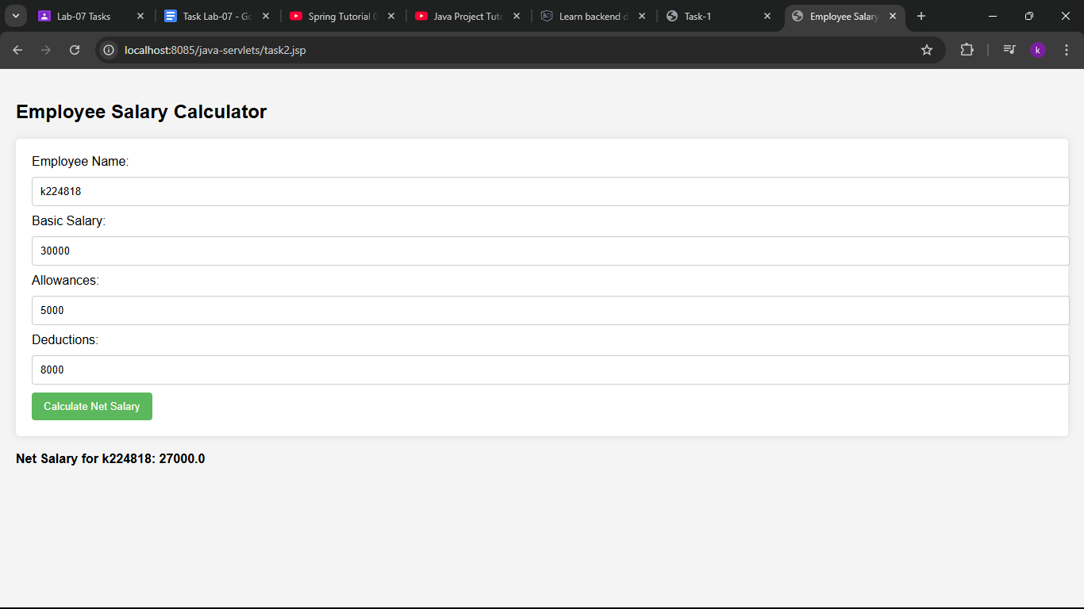

3)
<%@ page language="java" contentType="text/html; charset=UTF-8" pageEncoding="UTF-8"%>
<!DOCTYPE html>
<html>
<head>
<meta charset="UTF-8">
<title>User Information Form</title>
</head>
<body>
<h1>User Information Form</h1>
<form action="task3.jsp" method="post">
First Name: <input type="text" name="firstName" required><br>
Last Name: <input type="text" name="lastName" required><br>
Age: <input type="number" name="age" required><br>
<input type="submit" value="Submit">
</form>

<%
String firstName = request.getParameter("firstName");
String lastName = request.getParameter("lastName");
String ageString = request.getParameter("age");

if (firstName != null && lastName != null && ageString != null) {
int age = Integer.parseInt(ageString);
String fullName = firstName + " " + lastName;
String message;

if (age >= 18) {
message = "You are an Adult.";
} else {
message = "You are a Minor.";
}
%>
<h2>Your Information:</h2>
<p>Full Name: <%= fullName %></p>
<p><%= message %></p>
<%
}
%>
</body>
</html>

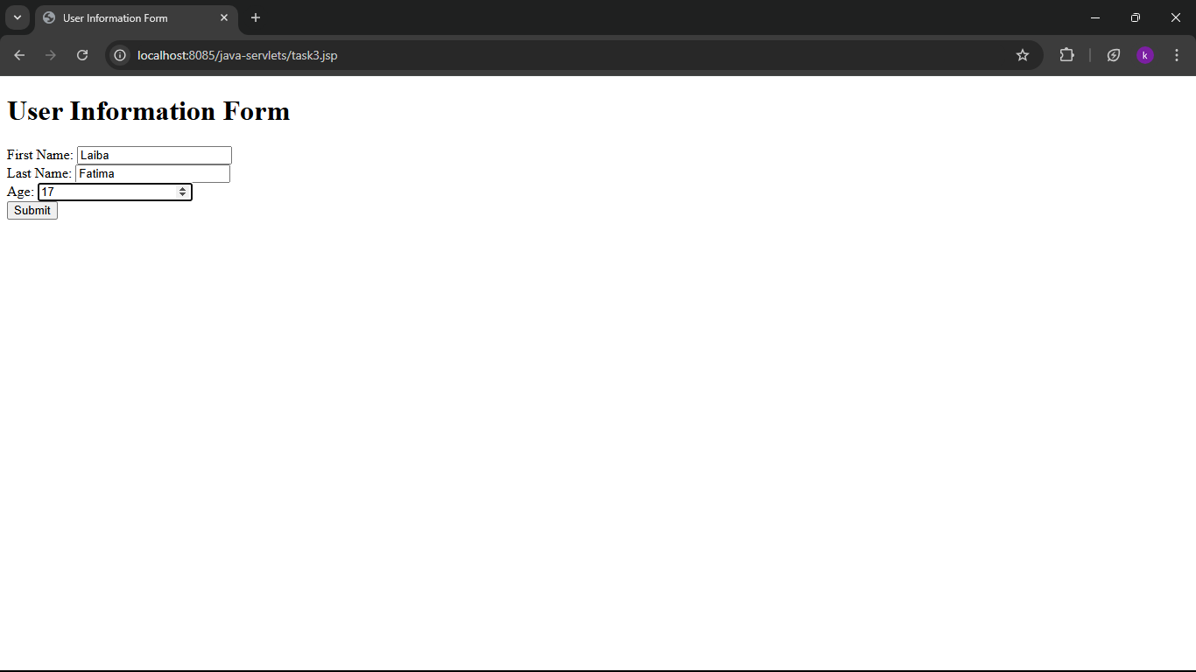
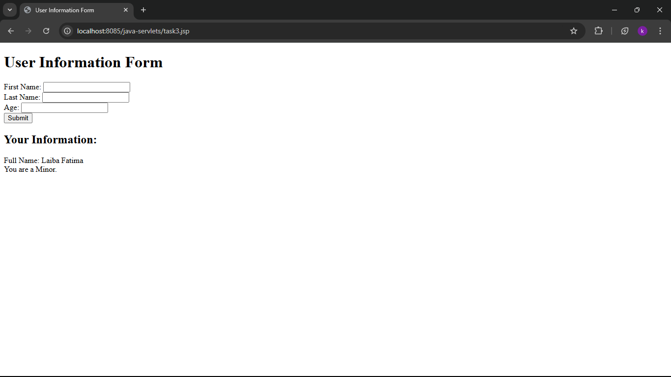
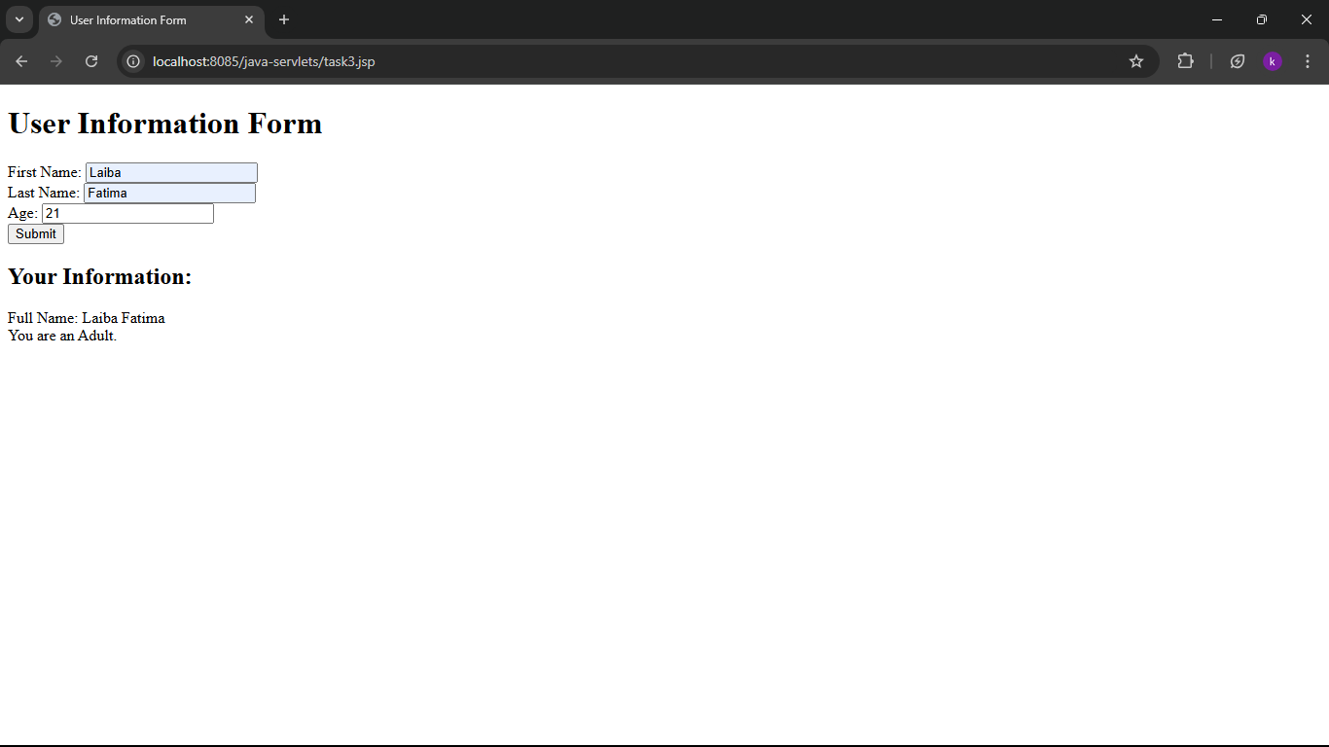

4)
<%@ page language="java" contentType="text/html; charset=UTF-8" pageEncoding="UTF-8"%>
<%!
// Method to calculate factorial
public long calculateFactorial(int n) {
if (n < 0) {
throw new IllegalArgumentException("Factorial is not defined for negative numbers.");
}
long factorial = 1;
for (int i = 1; i <= n; i++) {
factorial *= i;
}
return factorial;
}
%>
<!DOCTYPE html>
<html>
<head>
<meta charset="UTF-8">
<title>Factorial Calculator</title>
</head>
<body>
<h1>Factorial Calculator</h1>
<form action="task4.jsp" method="post">
Enter a number: <input type="number" name="number" required><br>
<input type="submit" value="Calculate Factorial">
</form>

<%
String numberString = request.getParameter("number");

if (numberString != null) {
int number = Integer.parseInt(numberString);
long factorial = calculateFactorial(number);
%>
<h2>Result:</h2>
<p>Factorial of <%= number %> is <%= factorial %>.</p>
<%
}
%>
</body>
</html>

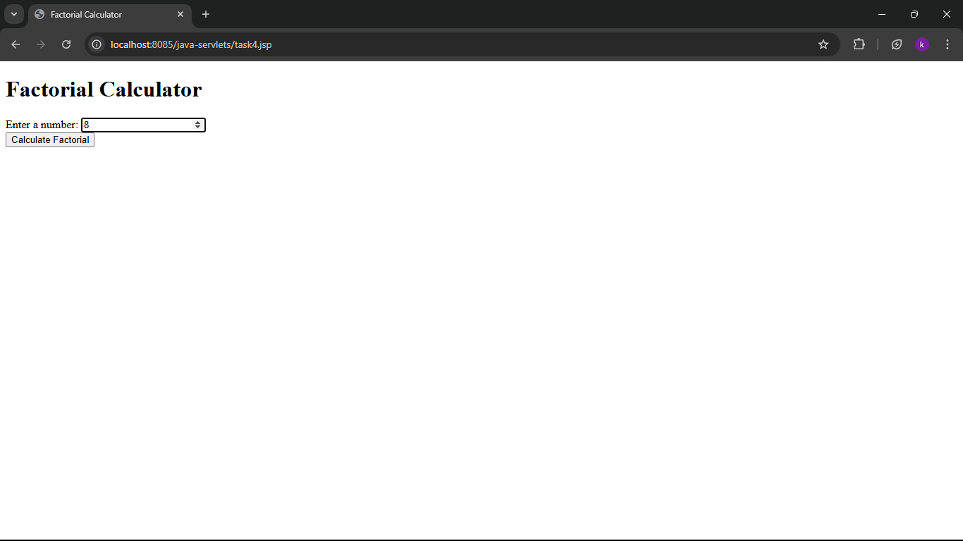
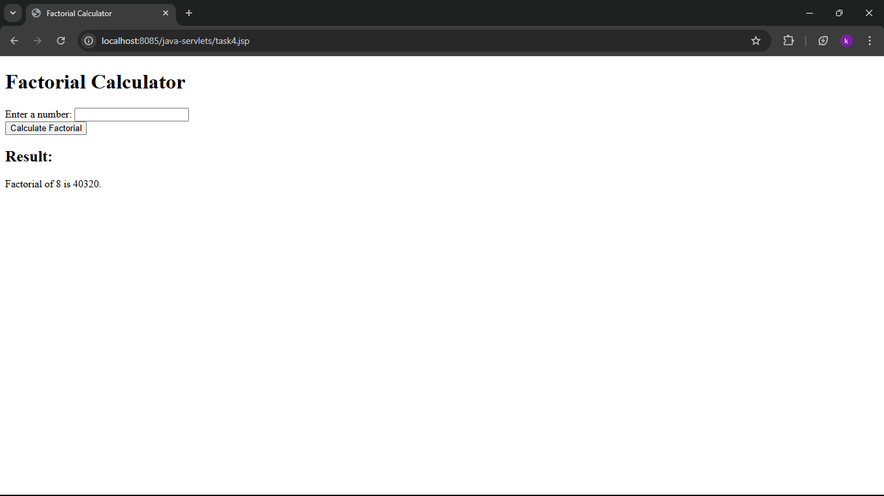

5)
<%@ page language="java" contentType="text/html; charset=UTF-8" pageEncoding="UTF-8"%>
<!DOCTYPE html>
<html>
<head>
<meta charset="UTF-8">
<title>Order Form</title>
</head>
<body>
<h1>Order Form</h1>
<form action="confirmation.jsp" method="post">
Email Address: <input type="email" name="email" required><br>
Product Name: <input type="text" name="product" required><br>
Quantity: <input type="number" name="quantity" min="1" required><br>
<input type="submit" value="Submit Order">
</form>
</body>
</html>

<%@ page language="java" contentType="text/html; charset=UTF-8" pageEncoding="UTF-8"%>
<%@ page import="java.io.*" %>
<%
String email = request.getParameter("email");
String product = request.getParameter("product");
String quantityString = request.getParameter("quantity");
int quantity = Integer.parseInt(quantityString);

if (email != null && product != null && quantity > 0) {
%>
<!DOCTYPE html>
<html>
<head>
<meta charset="UTF-8">
<title>Order Confirmation</title>
</head>
<body>
<h1>Order Confirmation</h1>
<p>Thank you for your order!</p>
<p>Email: <%= email %></p>
<p>Product: <%= product %></p>
<p>Quantity: <%= quantity %></p>
</body>
</html>
<%
} else {
response.sendRedirect("order.jsp");
}
%>

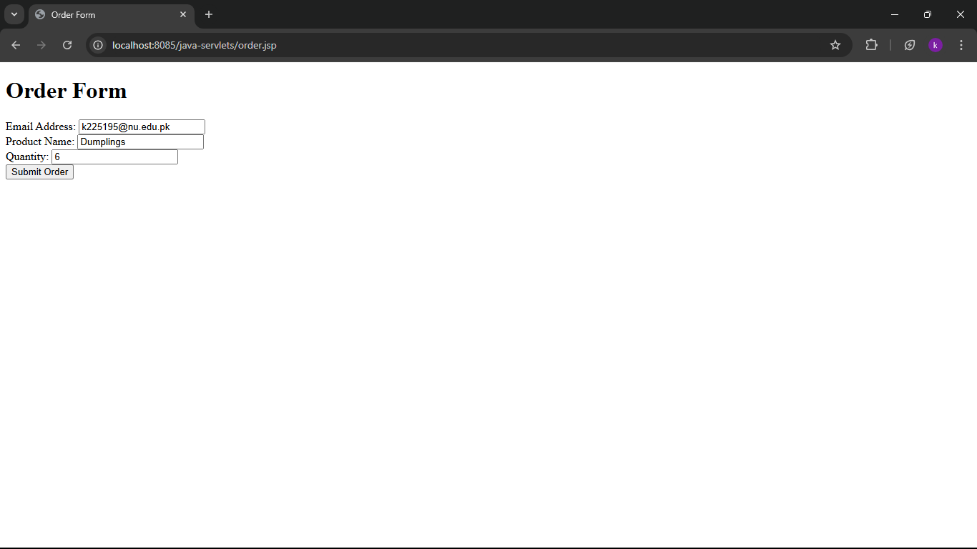
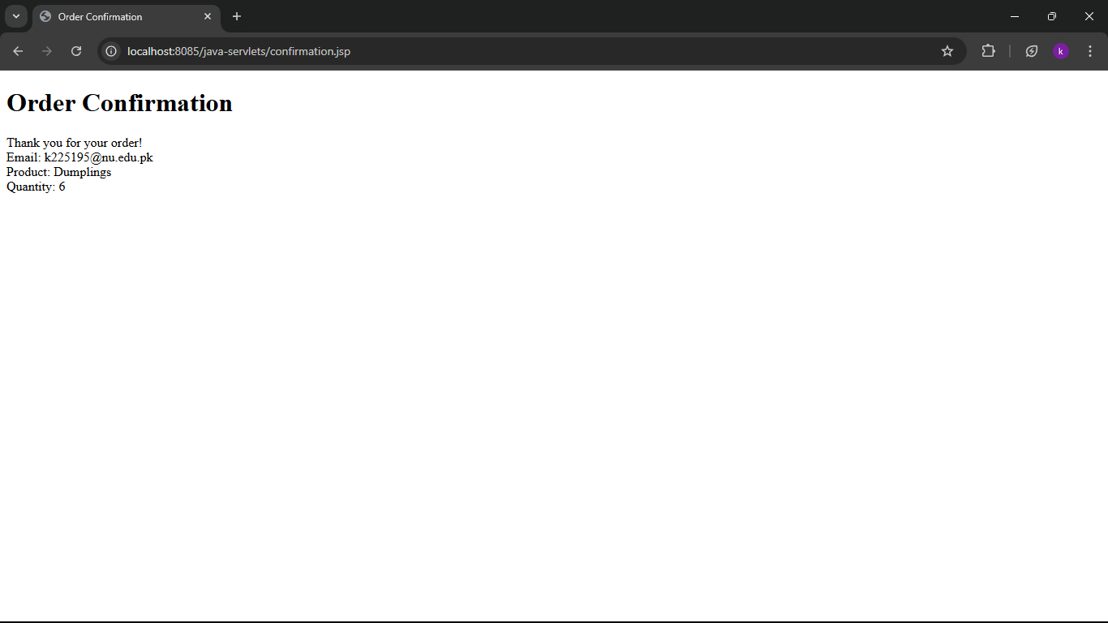

6)
<%@ page language="java" contentType="text/html; charset=UTF-8" pageEncoding="UTF-8"%>
<!DOCTYPE html>
<html>
<head>
<meta charset="UTF-8">
<title>User Input</title>
</head>
<body>
<h1>Enter Your Name</h1>
<form action="greetings.jsp" method="post">
First Name: <input type="text" name="firstName" required><br>
Last Name: <input type="text" name="lastName" required><br>
<input type="submit" value="Submit">
</form>
</body>
</html>

<%@ page language="java" contentType="text/html; charset=UTF-8" pageEncoding="UTF-8"%>
<%@ page import="java.io.*" %>
<%
String firstName = request.getParameter("firstName");
String lastName = request.getParameter("lastName");

if (firstName != null && lastName != null) {
%>
<!DOCTYPE html>
<html>
<head>
<meta charset="UTF-8">
<title>Greeting</title>
</head>
<body>
<h1>Hello, <%= firstName %> <%= lastName %>! Welcome to our website!</h1>
</body>
</html>
<%
} else {
response.sendRedirect("input.jsp");
}
%>
ss
